**Evaluation Only. Created with Aspose.Words. Copyright 2003-2023 Aspose Pty Ltd.**

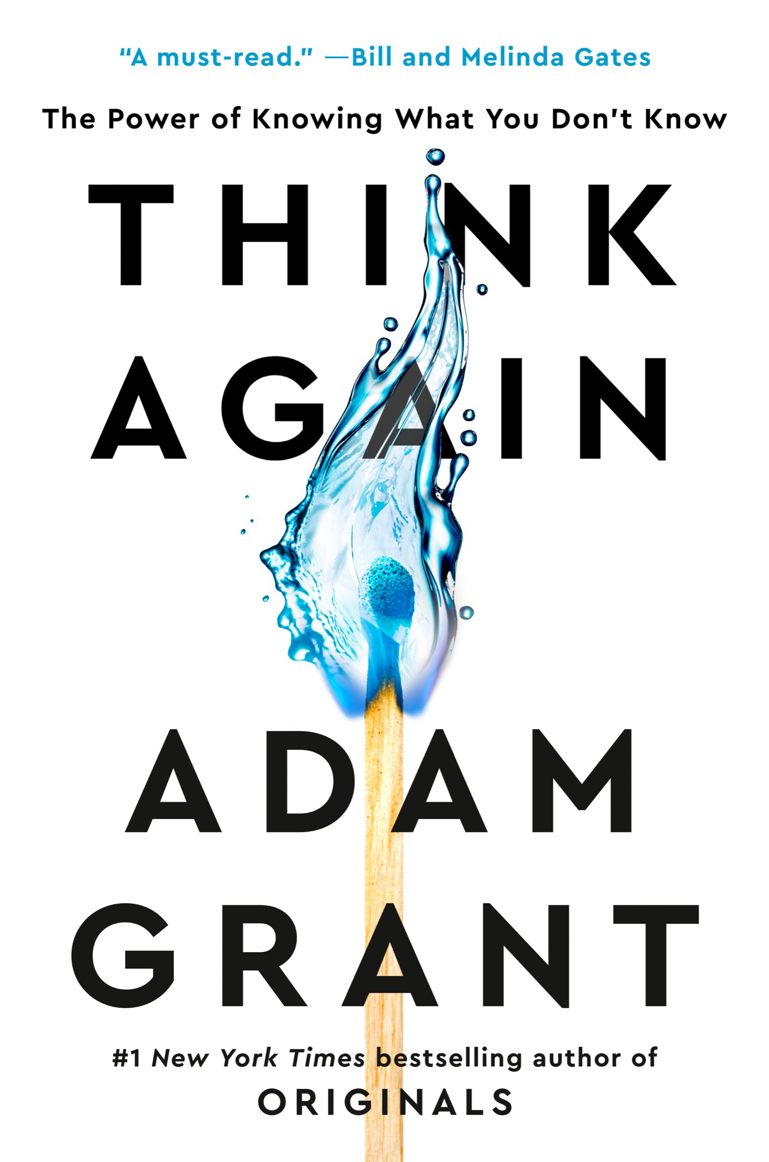

*Give and Take Originals Option B*

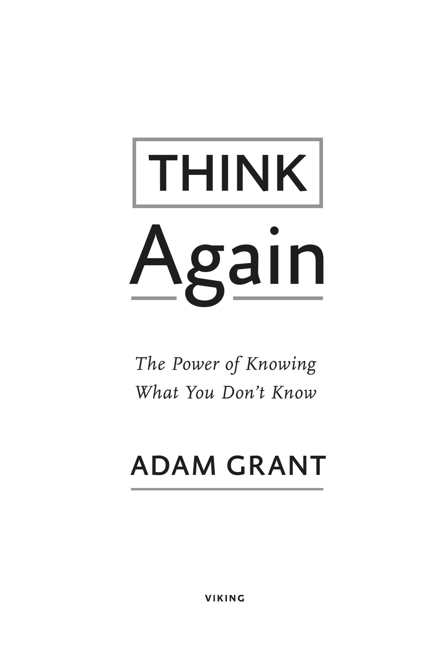

VIKING

An imprint of Penguin Random House LLC [penguinrandomhouse.com](http://www.penguinrandomhouse.com/)

Copyright © 2021 by Adam Grant

Penguin supports copyright. Copyright fuels creativity, encourages diverse voices, promotes free speech, and creates a vibrant culture. Thank you for buying an authorized edition of this book and for complying with copyright laws by not reproducing, scanning, or distributing any part of it in any form without permission. You are supporting writers and allowing Penguin to continue to publish books for every reader.

Owing to limitations of space, image credits can be found on this page. Unless otherwise noted, charts illustrated by Matt Shirley.

--

Names: Grant, Adam M., author.

Title: Think again : the power of knowing what you don’t know / Adam Grant. Description: [New York, New York] : Viking, [2021] | Includes bibliographical references and index.

Identifiers: LCCN 2020035237 (print) | LCCN 2020035238 (ebook) | ISBN 9781984878106 (hardcover) | ISBN 9781984878113 (ebook) |

ISBN 9780593298749 (international edition)

Subjects: LCSH: Thought and thinking. | Questioning. | Knowledge, Theory of. | Belief and doubt.

Classification: LCC BF441 .G693 2021 (print) | LCC BF441 (ebook) | DDC 153.4/2—dc23 LC record available at <https://lccn.loc.gov/2020035237>

LC ebook record available at <https://lccn.loc.gov/2020035238>

Book design by Daniel Lagin

While the author has made every effort to provide accurate telephone numbers, internet addresses, and other contact information at the time of publication, neither the publisher nor the author assumes any responsibility for errors or for changes that occur after publication. Further, the publisher does not have any control over and does not assume any responsibility for author or third-party websites or their content.

pid_prh_5.6.1_c0_r0

*To Kaan, Jeremy, and Bill,*

*My three oldest friends—one thing I won’t rethink*

**Prologue**

**PART I. Individual Rethinking**

*Updating Our Own Views*



1. A Preacher, a Prosecutor, a Politician, and a Scientist Walk into Your Mind
2. The Armchair Quarterback and the Impostor: Finding the Sweet Spot of Confidence
3. The Joy of Being Wrong: The Thrill of Not Believing Everything You Think
4. The Good Fight Club: The Psychology of Constructive Conflict

**PART II. Interpersonal Rethinking**

*Opening Other People’s Minds*



1. Dances with Foes: How to Win Debates and Influence People
2. Bad Blood on the Diamond: Diminishing Prejudice by Destabilizing Stereotypes
3. Vaccine Whisperers and Mild-Mannered Interrogators: How the Right Kind of Listening Motivates People to Change

**PART III. Collective Rethinking**

*Creating Communities of Lifelong Learners*



1. Charged Conversations: Depolarizing Our Divided Discussions
2. Rewriting the Textbook: Teaching Students to Question Knowledge
3. That’s Not the Way We’ve Always Done It: Building Cultures of Learning at Work

**PART IV. Conclusion**



1. Escaping Tunnel Vision: Reconsidering Our Best-Laid Career and Life Plans

**Epilogue**

**Actions for Impact**

**Acknowledgments** **Notes**

**Illustration Credits** **Index**

A fter a bumpy flight, fifteen men dropped from the Montanasky. They weren’t skydivers. They were smokejumpers: elitewildland firefighters parachuting in to extinguish a forest fire started by lightning the day before. In a matter of minutes, they

would be racing for their lives.

The smokejumpers landed near the top of Mann Gulch late on a scorching August afternoon in 1949. With the fire visible across the gulch, they made their way down the slope toward the Missouri River. Their plan was to dig a line in the soil around the fire to contain it and direct it toward an area where there wasn’t much to burn.

After hiking about a quarter mile, the foreman, Wagner Dodge, saw that the fire had leapt across the gulch and was heading straight at them. The flames stretched as high as 30 feet in the air. Soon the fire would be blazing fast enough to cross the length of two football fields in less than a minute.

By 5:45 p.m. it was clear that even containing the fire was off the table. Realizing it was time to shift gears from fight to flight, Dodge immediately turned the crew around to run back up the slope. The smokejumpers had to bolt up an extremely steep incline, throughknee-high grass on rocky terrain. Over the next eight minutes they traveled nearly 500 yards, leaving the top of the ridge less than 200 yards away.

With safety in sight but the fire swiftly advancing, Dodge did something that baffled his crew. Instead of trying to outrun the fire, he stopped and bent over. He took out a matchbook, started lighting matches, and threw them into the grass. “We thought he must have gone nuts,” one later recalled. “With the fire almost on our back,

what the hell is the boss doing lighting another fire in front of us?” He thought to himself: *That bastard Dodge is trying to burn me to death*. It’s no surprise that the crew didn’t follow Dodge when he waved his arms toward his fire and yelled, “Up! Up this way!”

What the smokejumpers didn’t realize was that Dodge had devised a survival strategy: he was building an escape fire. By burning the grass ahead of him, he cleared the area of fuel for the wildfire to feed on. He then poured water from his canteen onto his handkerchief, covered his mouth with it, and lay facedown in the charred area for the next fifteen minutes. As the wildfire raged directly above him, he survived in the oxygen close to the ground.

Tragically, twelve of the smokejumpers perished. A pocket watch belonging to one of the victims was later found with the hands melted at 5:56 p.m.

Why did only three of the smokejumpers survive? Physical fitness might have been a factor; the other two survivors managed to outrun the fire and reach the crest of the ridge. But Dodge prevailed because of his mental fitness.



on what it takes to be mentally fit, the firstidea that comes to mind is usually intelligence. The smarter you are,the more complex the problems you can solve—and the faster youcan solve them. Intelligence is traditionally viewed as the ability to think and learn. Yet in a turbulent world, there’s another set of cognitive skills that might matter more: the ability to rethink and unlearn.

Imagine that you’ve just finished taking a multiple-choice test, and you start to second-guess one of your answers. You have some extra time—should you stick with your first instinct or change it?

About three quarters of students are convinced that revising their answer will *hurt* their score. Kaplan, the big test-prep company,once warned students to “exercise great caution if you decide to change an answer. Experience indicates that many students who change answers change to the wrong answer.”

With all due respect to the lessons of experience, I prefer the rigor of evidence. When a trio of psychologists conducted a comprehensive review of thirty-three studies, they found that in

every one, the majority of answer revisions were from wrong to right. This phenomenon is known as the first-instinct fallacy.

In one demonstration, psychologists counted eraser marks on the exams of more than 1,500 students in Illinois. Only a quarter of the changes were from right to wrong, while half were from wrong to right. I’ve seen it in my own classroom year after year: my students’ final exams have surprisingly few eraser marks, but those who do rethink their first answers rather than staying anchored to them end up improving their scores.

Of course, it’s possible that second answers aren’t inherently better; they’re only better because students are generally so reluctant to switch that they only make changes when they’re fairly confident. But recent studies point to a different explanation: it’s not so much changing your answer that improves your score as considering whether you should change it.

We don’t just hesitate to rethink our answers. We hesitate at the very idea of rethinking. Take an experiment where hundreds of college students were randomly assigned to learn about the first- instinct fallacy. The speaker taught them about the value of changing their minds and gave them advice about when it made sense to do so. On their next two tests, they still weren’t any more likely to revise their answers.

Part of the problem is cognitive laziness. Some psychologists point out that we’re mental misers: we often prefer the ease of hanging on to old views over the difficulty of grappling with new ones. Yet there are also deeper forces behind our resistance to rethinking. Questioning ourselves makes the world more unpredictable. It requires us to admit that the facts may have changed, that what was once right may now be wrong. Reconsidering something we believe deeply can threaten our identities, making it feel as if we’re losing a part of ourselves.

Rethinking isn’t a struggle in every part of our lives. When it comes to our possessions, we update with fervor. We refresh our wardrobes when they go out of style and renovate our kitchens when they’re no longer in vogue. When it comes to our knowledge and opinions, though, we tend to stick to our guns. Psychologists call this seizing and freezing. We favor the comfort of conviction over the discomfort of doubt, and we let our beliefs get brittle long before our bones. We laugh at people who still use Windows 95, yet we still cling to opinions that we formed in 1995. We listen to views that make us feel good, instead of ideas that make us think hard.

At some point, you’ve probably heard that if you drop a frog in a pot of scalding hot water, it will immediately leap out. But if you drop the frog in lukewarm water and gradually raise the temperature, the frog will die. It lacks the ability to rethink the situation, and doesn’t realize the threat until it’s too late.

I did some research on this popular story recently and discovered a wrinkle: it isn’t true.

Tossed into the scalding pot, the frog will get burned badly and may or may not escape. The frog is actually better off in the slow- boiling pot: it will leap out as soon as the water starts to get uncomfortably warm.

It’s not the frogs who fail to reevaluate. It’s us. Once we hear the story and accept it as true, we rarely bother to question it.



raced toward them, the smokejumpers had a decision to make. In an ideal world, they would have had enough time to pause, analyze the situation, and evaluate their options. With the fire raging less than 100 yards behind, there wasno chance to stop and think. “On a big fire there is no time and no tree under whose shade the boss and the crew can sit and have a Platonic dialogue about a blowup,” scholar and former firefighter Norman Maclean wrote in *Young Men and Fire*, his award-winning chronicle of the disaster. “If Socrates had been foreman on the Mann Gulch fire, he and his crew would have been cremated while they were sitting there considering it.”

Dodge didn’t survive as a result of thinking slower. He made it out alive thanks to his ability to rethink the situation faster. Twelve smokejumpers paid the ultimate price because Dodge’s behavior didn’t make sense to them. They couldn’t rethink their assumptions in time.

Under acute stress, people typically revert to their automatic, well-learned responses. That’s evolutionarily adaptive—as long as you find yourself in the same kind of environment in which those reactions were necessary. If you’re a smokejumper, your well-learned response is to put out a fire, not start another one. If you’re fleeing for your life, your well-learned response is to run away from the fire,

not toward it. In normal circumstances, those instincts might save your life. Dodge survived Mann Gulch because he swiftly overrode both of those responses.

No one had taught Dodge to build an escape fire. He hadn’t even heard of the concept; it was pure improvisation. Later, the other two survivors testified under oath that nothing resembling an escape fire was covered in their training. Many experts had spent their entire careers studying wildfires without realizing it was possible to stay alive by burning a hole through the blaze.

When I tell people about Dodge’s escape, they usually marvel at his resourcefulness under pressure. *That was genius!* Their astonishment quickly melts into dejection as they conclude that this kind of eureka moment is out of reach for mere mortals. *I got stumped by my fourth grader’s* *math homework.* Yet most acts of rethinking don’t require any special skill or ingenuity.

Moments earlier at Mann Gulch, the smokejumpers missed another opportunity to think again—and that one was right at their fingertips. Just before Dodge started tossing matches into the grass, he ordered his crew to drop their heavy equipment. They had spent the past eight minutes racing uphill while still carrying axes, saws, shovels, and 20-pound packs.

If you’re running for your life, it might seem obvious that your first move would be to drop anything that might slow you down. For firefighters, though, tools are essential to doing their jobs. Carrying and taking care of equipment is deeply ingrained in their training and experience. It wasn’t until Dodge gave his order that most of the smokejumpers set down their tools—and even then, one firefighter hung on to his shovel until a colleague took it out of his hands. If the crew had abandoned their tools sooner, would it have been enough to save them?

We’ll never know for certain, but Mann Gulch wasn’t an isolated incident. Between 1990 and 1995 alone, a total of twenty-three wildland firefighters perished trying to outrace fires uphill even though dropping their heavy equipment could have made the difference between life and death. In 1994, on Storm King Mountain in Colorado, high winds caused a fire to explode across a gulch. Running uphill on rocky ground with safety in view just 200 feet away, fourteen smokejumpers and wildland firefighters—four women, ten men—lost their lives.

Later, investigators calculated that without their tools and backpacks, the crew could have moved 15 to 20 percent faster. “Most would have lived had they simply dropped their gear and run for safety,” one expert wrote. Had they “dropped their packs and tools,” the U.S. Forest Service concurred, “the firefighters would have reached the top of the ridge before the fire.”

It’s reasonable to assume that at first the crew might have been running on autopilot, not even aware that they were still carrying their packs and tools. “About three hundred yards up the hill,” one of the Colorado survivors testified, “I then realized I still had my saw over my shoulder!” Even after making the wise decision to ditch the 25-pound chainsaw, he wasted valuable time: “I irrationally started looking for a place to put it down where it wouldn’t get burned. . . . I remember thinking, ‘I can’t believe I’m putting down my saw.’” One of the victims was found wearing his backpack, still clutching the handle of his chainsaw. Why would so many firefighters cling to a set of tools even though letting go might save their lives?

If you’re a firefighter, dropping your tools doesn’t just require you to unlearn habits and disregard instincts. Discarding your equipment means admitting failure and shedding part of your identity. You have to rethink your goal in your job—and your role in life. “Fires are not fought with bodies and bare hands, they are fought with tools that are often distinctive trademarks of firefighters,” organizational psychologist Karl Weick explains: “They are the firefighter’s reason for being deployed in the first place. . . . Dropping one’s tools creates an existential crisis. Without my tools, who am I?”

Wildland fires are relatively rare. Most of our lives don’t depend on split-second decisions that force us to reimagine our tools as a source of danger and a fire as a path to safety. Yet the challenge of rethinking assumptions is surprisingly common—maybe even common to all humans.

We all make the same kind of mistakes as smokejumpers and firefighters, but the consequences are less dire and therefore often go unnoticed. Our ways of thinking become habits that can weigh us down, and we don’t bother to question them until it’s too late. Expecting your squeaky brakes to keep working until they finally fail on the freeway. Believing the stock market will keep going up after analysts warn of an impending real estate bubble. Assuming your marriage is fine despite your partner’s increasing emotional distance. Feeling secure in your job even though some of your colleagues have been laid off.

This book is about the value of rethinking. It’s about adopting the kind of mental flexibility that saved Wagner Dodge’s life. It’s also about succeeding where he failed: encouraging that same agility in others.

You may not carry an ax or a shovel, but you do have some cognitive tools that you use regularly. They might be things you know, assumptions you make, or opinions you hold. Some of them aren’t just part of your job—they’re part of your sense of self.

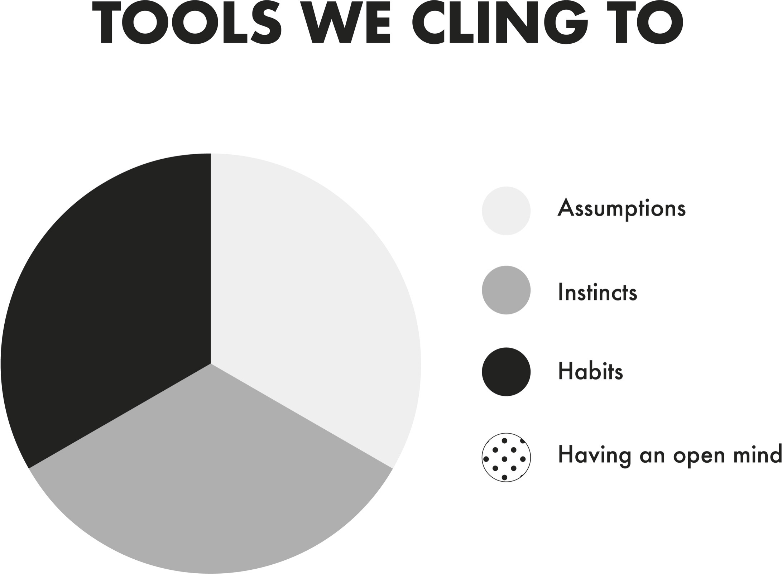

Consider a group of students who built what has been calledHarvard’s first online social network. Before they arrived at college, they had already connected more than an eighth of the enteringfreshman class in an “e-group.” But once they got to Cambridge, they abandoned the network and shut it down. Five years later Mark Zuckerberg started Facebook on the same campus.

From time to time, the students who created the original e-group have felt some pangs of regret. I know, because I was one of the cofounders of that group.

Let’s be clear: I never would have had the vision for what Facebook became. In hindsight, though, my friends and I clearly missed a series of chances for rethinking the potential of our platform. Our first instinct was to use the e-group to make new friends for ourselves; we didn’t consider whether it would be of interest to students at other schools or in life beyond school. Our well-learned habit was to use online tools to connect with people far away; once we lived within walking distance on the same campus, we figured we no longer needed the e-group. Although one of the cofounders was studying computer science and another early member had already founded a successful tech startup, we made the flawed assumption that an online social network was a passing hobby, not a huge part of the future of the internet. Since I didn’t know how to code, I didn’t have the tools to build something more sophisticated. Launching a company wasn’t part of my identity anyway: I saw myself as a college freshman, not a budding entrepreneur.

Since then, rethinking has become central to my sense of self. I’m a psychologist but I’m not a fan of Freud, I don’t have a couch in my office, and I don’t do therapy. As an organizational psychologist at Wharton, I’ve spent the past fifteen years researching and teaching evidence-based management. As an entrepreneur of data and ideas, I’ve been called by organizations like Google, Pixar, the NBA, and the Gates Foundation to help them reexamine how they design meaningful jobs, build creative teams, and shape collaborative cultures. My job is to think again about how we work, lead, and live— and enable others to do the same.

I can’t think of a more vital time for rethinking. As the coronavirus pandemic unfolded, many leaders around the world were slow to rethink their assumptions—first that the virus wouldn’t affect their countries, next that it would be no deadlier than the flu, and then that it could only be transmitted by people with visible symptoms. The cost in human life is still being tallied.

In the past year we’ve all had to put our mental pliability to the test. We’ve been forced to question assumptions that we had long taken for granted: That it’s safe to go to the hospital, eat in a restaurant, and hug our parents or grandparents. That live sports will always be on TV and most of us will never have to work remotely or homeschool our kids. That we can get toilet paper and hand sanitizer whenever we need them.

In the midst of the pandemic, multiple acts of police brutality led many people to rethink their views on racial injustice and their roles in fighting it. The senseless deaths of three Black citizens—George Floyd, Breonna Taylor, and Ahmaud Arbery—left millions of white people realizing that just as sexism is not only a women’s issue, racism is not only an issue for people of color. As waves of protest swept the nation, across the political spectrum, support for the Black Lives Matter movement climbed nearly as much in the span of two weeks as it had in the previous two years. Many of those who had long been unwilling or unable to acknowledge it quickly came to grips with the harsh reality of systemic racism that still pervades America. Many of those who had long been silent came to reckon with their responsibility to become antiracists and act against prejudice.

Despite these shared experiences, we live in an increasingly divisive time. For some people a single mention of kneeling during the national anthem is enough to end a friendship. For others a single ballot at a voting booth is enough to end a marriage. Calcified ideologies are tearing American culture apart. Even our great governing document, the U.S. Constitution, allows for amendments. What if we were quicker to make amendments to our own mental constitutions?

My aim in this book is to explore how rethinking happens. I sought out the most compelling evidence and some of the world’s most skilled rethinkers. The first section focuses on opening our own minds. You’ll find out why a forward-thinking entrepreneur got trapped in the past, why a long-shot candidate for public office came to see impostor syndrome as an advantage, how a Nobel Prize– winning scientist embraces the joy of being wrong, how the world’s best forecasters update their views, and how an Oscar-winning filmmaker has productive fights.

The second section examines how we can encourage other people to think again. You’ll learn how an international debate champion wins arguments and a Black musician persuades white supremacists to abandon hate. You’ll discover how a special kind of listening helped a doctor open parents’ minds about vaccines, and helped a legislator convince a Ugandan warlord to join her in peace talks. And if you’re a Yankees fan, I’m going to see if I can convince you to root for the Red Sox.

The third section is about how we can create communities of lifelong learners. In social life, a lab that specializes in difficult conversations will shed light on how we can communicate better about polarizing issues like abortion and climate change. In schools, you’ll find out how educators teach kids to think again by treating classrooms like museums, approaching projects like carpenters, and rewriting time-honored textbooks. At work, you’ll explore how to build learning cultures with the first Hispanic woman in space, who took the reins at NASA to prevent accidents after space shuttle *Columbia* disintegrated. I close by reflecting on the importance of reconsidering our best-laid plans.

It’s a lesson that firefighters have learned the hard way. In the heat of the moment, Wagner Dodge’s impulse to drop his heavy tools and take shelter in a fire of his own making made the difference between life and death. But his inventiveness wouldn’t have even been necessary if not for a deeper, more systemic failure to think again. The greatest tragedy of Mann Gulch is that a dozen smokejumpers died fighting a fire that never needed to be fought.

As early as the 1880s, scientists had begun highlighting the important role that wildfires play in the life cycles of forests. Fires remove dead matter, send nutrients into the soil, and clear a path for sunlight. When fires are suppressed, forests are left too dense. The accumulation of brush, dry leaves, and twigs becomes fuel for more explosive wildfires.

Yet it wasn’t until 1978 that the U.S. Forest Service put an end to its policy that every fire spotted should be extinguished by 10:00 a.m. the following day. The Mann Gulch wildfire took place in a remote area where human lives were not at risk. The smokejumpers were called in anyway because no one in their community, their organization, or their profession had done enough to question the assumption that wildfires should not be allowed to run their course.

This book is an invitation to let go of knowledge and opinions that are no longer serving you well, and to anchor your sense of self in flexibility rather than consistency. If you can master the art of rethinking, I believe you’ll be better positioned for success at work and happiness in life. Thinking again can help you generate new solutions to old problems and revisit old solutions to new problems.

It’s a path to learning more from the people around you and living with fewer regrets. A hallmark of wisdom is knowing when it’s time to abandon some of your most treasured tools—and some of the most cherished parts of your identity.

**Individual Rethinking**



*Updating Our Own Views*

**A Preacher, a Prosecutor, a Politician, and a Scientist Walk into Your Mind**



Progress is impossible without change; and those who cannot change their minds cannot change anything.

—

Y ou probably don’t recognize his name, but Mike Lazaridis has

had a defining impact on your life. From an early age, it was

clear that Mike was something of an electronics wizard. By the time he turned four, he was building his own record player out of Legos and rubber bands. In high school, when his teachers had broken TVs, they called Mike to fix them. In his spare time, he built a computer and designed a better buzzer for high school quiz-bowl teams, which ended up paying for his first year of college. Just months before finishing his electrical engineering degree, Mike did what so many great entrepreneurs of his era would do: he dropped out of college. It was time for this son of immigrants to make his mark on the world.

Mike’s first success came when he patented a device for readingthe bar codes on movie film, which was so useful in Hollywood that it won an Emmy and an Oscar for technical achievement. That was small potatoes compared to his next big invention, which made hisfirm the fastest-growing company on the planet. Mike’s flagship device quickly attracted a cult following, with loyal customers ranging from Bill Gates to Christina Aguilera. “It’s literally changed my life,” Oprah Winfrey gushed. “I cannot live without this.” When

he arrived at the White House, President Obama refused to relinquish his to the Secret Service.

Mike Lazaridis dreamed up the idea for the BlackBerry as a wireless communication device for sending and receiving emails. As of the summer of 2009, it accounted for nearly half of the U.S. smartphone market. By 2014, its market share had plummeted to less than 1 percent.

When a company takes a nosedive like that, we can never pinpoint a single cause of its downfall, so we tend to anthropomorphize it: *BlackBerry failed to adapt.* Yet adapting to a changing environment isn’t something a company does—it’s something *people* do in the multitude of decisions they make every day. As the cofounder, president, and co-CEO, Mike was in charge of all the technical and product decisions on the BlackBerry. Although his thinking may have been the spark that ignited the smartphone revolution, his struggles with rethinking ended up sucking the oxygen out of his company and virtually extinguishing his invention. Where did he go wrong?

Most of us take pride in our knowledge and expertise, and in staying true to our beliefs and opinions. That makes sense in a stable world, where we get rewarded for having conviction in our ideas. The problem is that we live in a rapidly changing world, where we need to spend as much time rethinking as we do thinking.

Rethinking is a skill set, but it’s also a mindset. We already have many of the mental tools we need. We just have to remember to get them out of the shed and remove the rust.

**SECOND THOUGHTS**



With advances in access to information and technology, knowledge isn’t just increasing. It’s increasing at an increasing rate. In 2011, youconsumed about five times as much information per day as you would have just a quarter century earlier. As of 1950, it took aboutfifty years for knowledge in medicine to double. By 1980, medical knowledge was doubling every seven years, and by 2010, it was doubling in half that time. The accelerating pace of change means that we need to question our beliefs more readily than ever before.

This is not an easy task. As we sit with our beliefs, they tend to become more extreme and more entrenched. *I’m still struggling to accept that Pluto may not be a planet.* In education, after revelations in history and revolutions in science, it often takes years for a curriculum to be updated and textbooks to be revised. Researchers have recently discovered that we need to rethink widely accepted assumptions about such subjects as Cleopatra’s roots (her father was Greek, not Egyptian, and her mother’s identity is unknown); the appearance of dinosaurs (paleontologists now think some tyrannosaurs had colorful feathers on their backs); and what’s required for sight (blind people have actually trained themselves to “see”—sound waves can activate the visual cortex and create representations in the mind’s eye, much like how echolocation helps bats navigate in the dark).* Vintage records, classic cars, and antique clocks might be valuable collectibles, but outdated facts are mental fossils that are best abandoned.

We’re swift to recognize when other people need to think again. We question the judgment of experts whenever we seek out a second opinion on a medical diagnosis. Unfortunately, when it comes to our own knowledge and opinions, we often favor *feeling* right over *being* right. In everyday life, we make many diagnoses of our own, ranging from whom we hire to whom we marry. We need to develop the habit of forming our own second opinions.

Imagine you have a family friend who’s a financial adviser, and he recommends investing in a retirement fund that isn’t in your employer’s plan. You have another friend who’s fairly knowledgeable about investing, and he tells you that this fund is risky. What would you do?

When a man named Stephen Greenspan found himself in that situation, he decided to weigh his skeptical friend’s warning against the data available. His sister had been investing in the fund for several years, and she was pleased with the results. A number of her friends had been, too; although the returns weren’t extraordinary, they were consistently in the double digits. The financial adviser was enough of a believer that he had invested his own money in the fund. Armed with that information, Greenspan decided to go forward. He made a bold move, investing nearly a third of his retirement savings in the fund. Before long, he learned that his portfolio had grown by 25 percent.

Then he lost it all overnight when the fund collapsed. It was the Ponzi scheme managed by Bernie Madoff.

Two decades ago my colleague Phil Tetlock discovered something peculiar. As we think and talk, we often slip into the mindsets of three different professions: preachers, prosecutors, and politicians. In each of these modes, we take on a particular identity and use a distinct set of tools. We go into preacher mode when our sacred beliefs are in jeopardy: we deliver sermons to protect and promote our ideals. We enter prosecutor mode when we recognize flaws in other people’s reasoning: we marshal arguments to prove them wrong and win our case. We shift into politician mode when we’re seeking to win over an audience: we campaign and lobby for the approval of our constituents. The risk is that we become so wrapped up in preaching that we’re right, prosecuting others who are wrong, and politicking for support that we don’t bother to rethink our own views.

When Stephen Greenspan and his sister made the choice to invest with Bernie Madoff, it wasn’t because they relied on just one of those mental tools. All three modes together contributed to their ill- fated decision. When his sister told him about the money she and her friends had made, she was preaching about the merits of the fund. Her confidence led Greenspan to prosecute the friend who warned him against investing, deeming the friend guilty of “knee-jerk cynicism.” Greenspan was in politician mode when he let his desire for approval sway him toward a yes—the financial adviser was a family friend whom he liked and wanted to please.

Any of us could have fallen into those traps. Greenspan says that he should’ve known better, though, because he happens to be an expert on gullibility. When he decided to go ahead with the investment, he had almost finished writing a book on why we get duped. Looking back, he wishes he had approached the decision with a different set of tools. He might have analyzed the fund’s strategy more systematically instead of simply trusting in the results. He could have sought out more perspectives from credible sources. He would have experimented with investing smaller amounts over a longer period of time before gambling so much of his life’s savings.

That would have put him in the mode of a scientist.

**A DIFFERENT PAIR OF GOGGLES**



If you’re a scientist by trade, rethinking is fundamental to your profession. You’re paid to be constantly aware of the limits of your understanding. You’re expected to doubt what you know, be curiousabout what you don’t know, and update your views based on new data. In the past century alone, the application of scientific principles has led to dramatic progress. Biological scientists discovered penicillin. Rocket scientists sent us to the moon. Computer scientists built the internet.

But being a scientist is not just a profession. It’s a frame of mind —a mode of thinking that differs from preaching, prosecuting, and politicking. We move into scientist mode when we’re searching for the truth: we run experiments to test hypotheses and discover knowledge. Scientific tools aren’t reserved for people with white coats and beakers, and using them doesn’t require toiling away for years with a microscope and a petri dish. Hypotheses have as much of a place in our lives as they do in the lab. Experiments can inform our daily decisions. That makes me wonder: is it possible to train people in other fields to think more like scientists, and if so, do they end up making smarter choices?

Recently, a quartet of European researchers decided to find out. They ran a bold experiment with more than a hundred founders of Italian startups in technology, retail, furniture, food, health care, leisure, and machinery. Most of the founders’ businesses had yet to bring in any revenue, making it an ideal setting to investigate how teaching scientific thinking would influence the bottom line.

The entrepreneurs arrived in Milan for a training program in entrepreneurship. Over the course of four months, they learned to create a business strategy, interview customers, build a minimum viable product, and then refine a prototype. What they didn’t know was that they’d been randomly assigned to either a “scientific thinking” group or a control group. The training for both groups wasidentical, except that one was encouraged to view startups through a scientist’s goggles. From that perspective, their strategy is a theory, customer interviews help to develop hypotheses, and their minimum viable product and prototype are experiments to test those hypotheses. Their task is to rigorously measure the results and make decisions based on whether their hypotheses are supported or refuted.

Over the following year, the startups in the control group averaged under $300 in revenue. The startups in the scientific thinking group averaged over $12,000 in revenue. They brought in revenue more than twice as fast—and attracted customers sooner, too. Why? The entrepreneurs in the control group tended to stay wedded to their original strategies and products. It was too easy to preach the virtues of their past decisions, prosecute the vices of alternative options, and politick by catering to advisers who favored the existing direction. The entrepreneurs who had been taught to think like scientists, in contrast, pivoted more than twice as often. When their hypotheses weren’t supported, they knew it was time to rethink their business models.

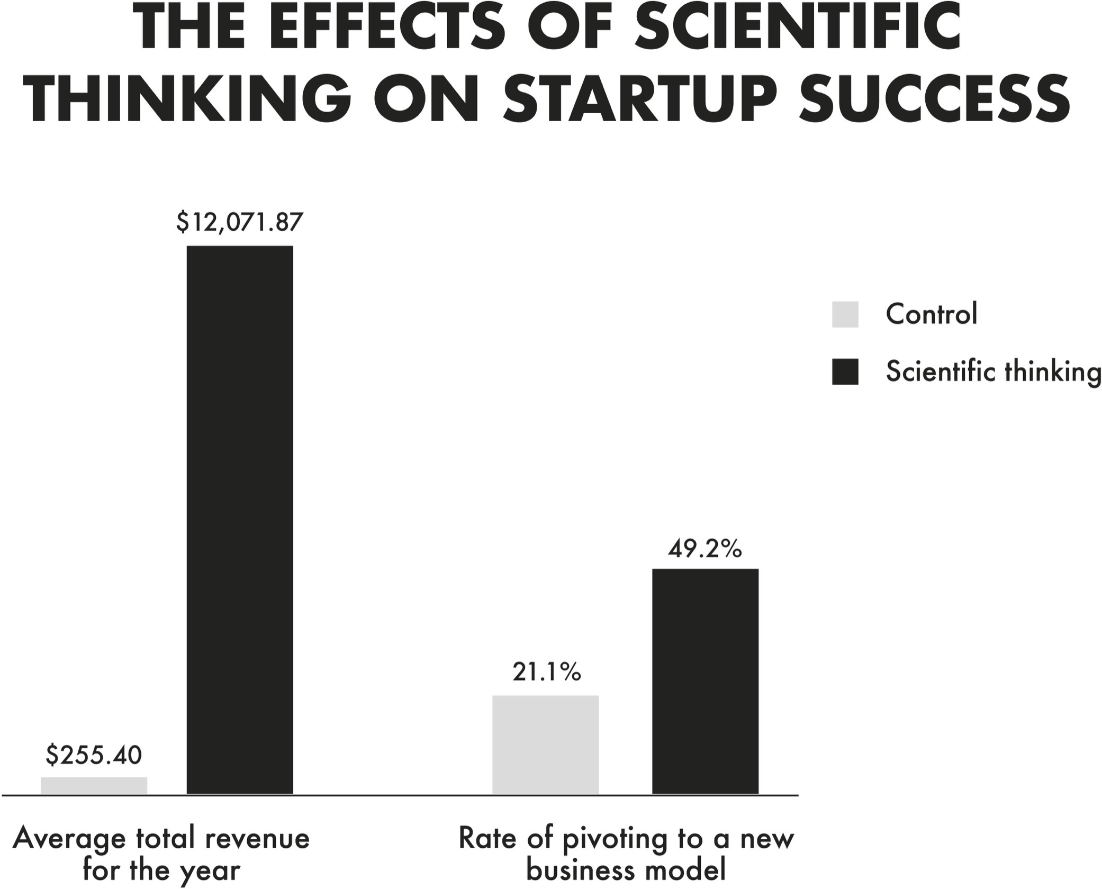

What’s surprising about these results is that we typically celebrate great entrepreneurs and leaders for being strong-minded and clear-sighted. They’re supposed to be paragons of conviction: decisive and certain. Yet evidence reveals that when business executives compete in tournaments to price products, the best strategists are actually slow and unsure. Like careful scientists, they take their time so they have the flexibility to change their minds. *I’m beginning to think decisiveness is overrated . . . but I reserve the right to change my mind.*

Just as you don’t have to be a professional scientist to reason like one, being a professional scientist doesn’t guarantee that someone will use the tools of their training. Scientists morph into preachers when they present their pet theories as gospel and treat thoughtful critiques as sacrilege. They veer into politician terrain when they allow their views to be swayed by popularity rather than accuracy. They enter prosecutor mode when they’re hell-bent on debunking and discrediting rather than discovering. After upending physics with his theories of relativity, Einstein opposed the quantum revolution: “To punish me for my contempt of authority, Fate has made me an authority myself.” Sometimes even great scientists need to think more like scientists.

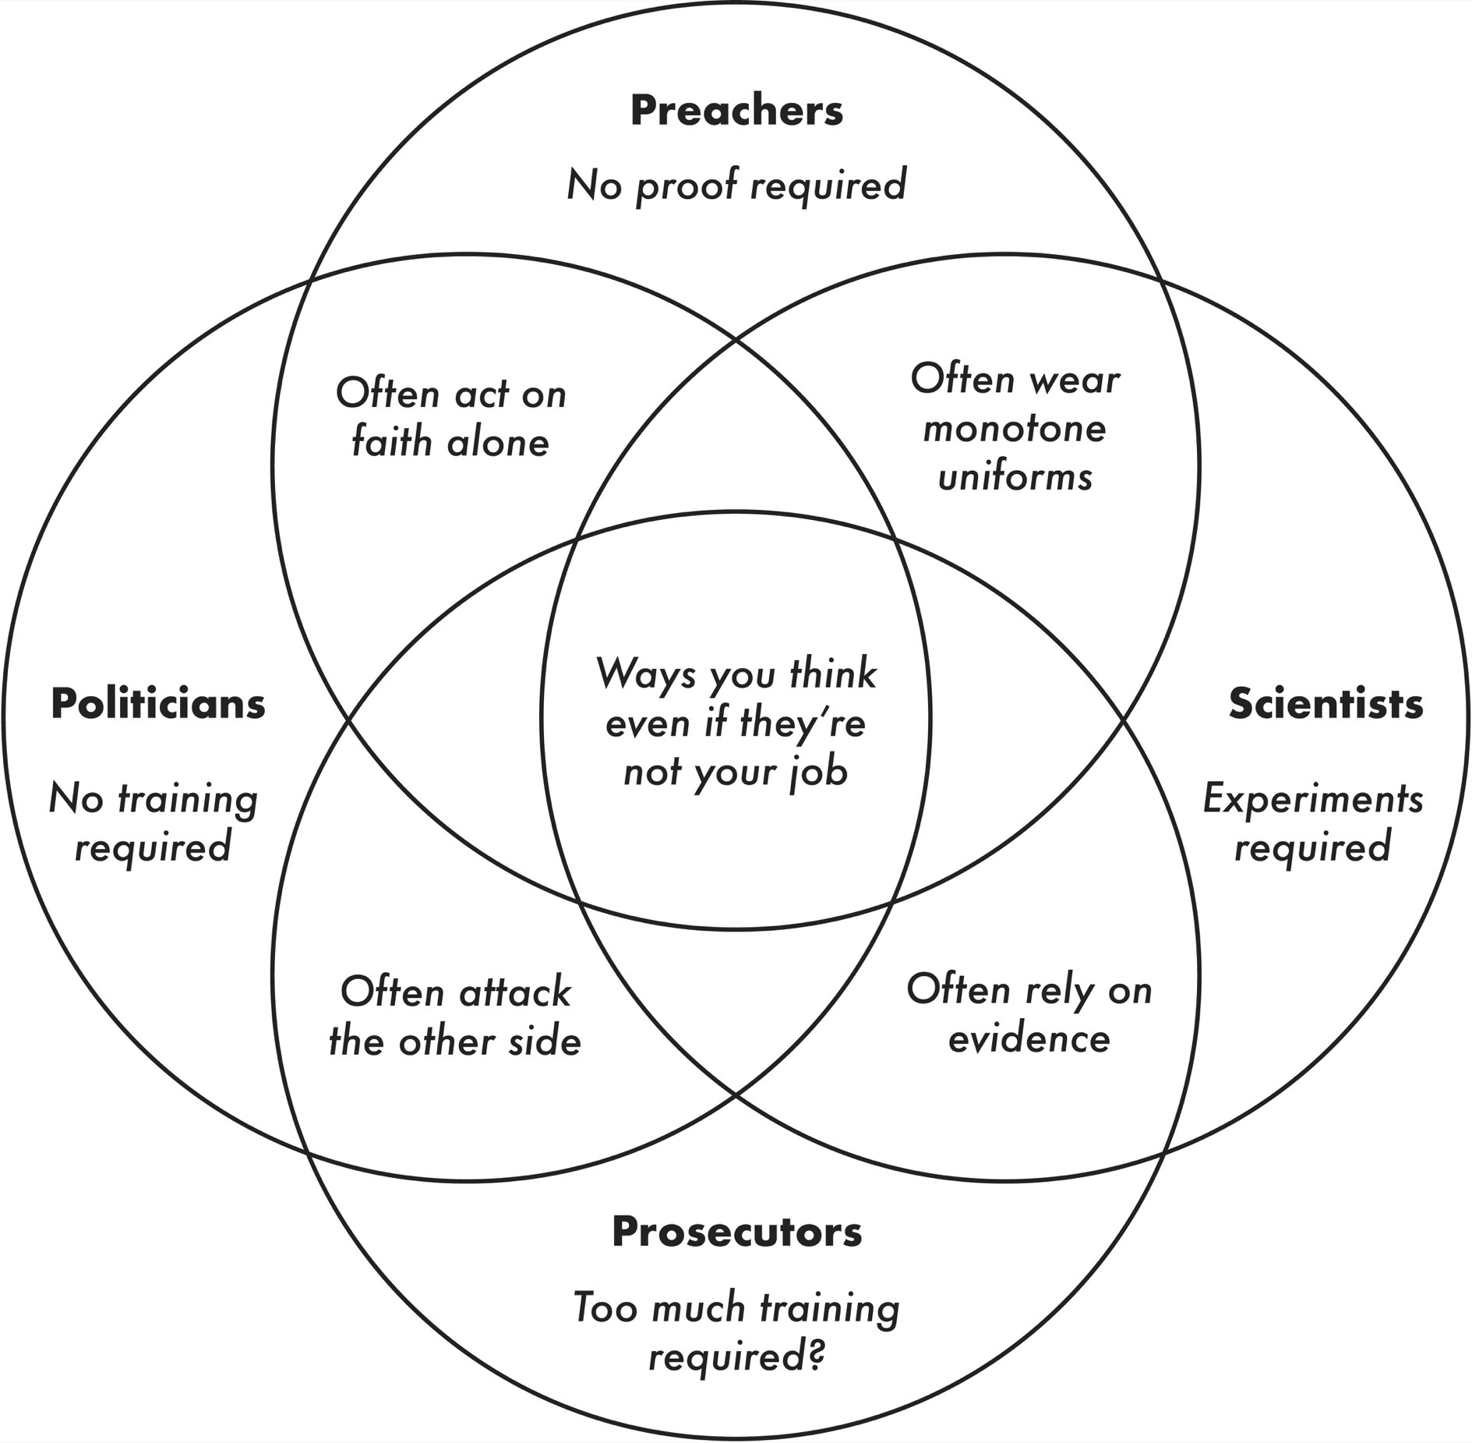

Decades before becoming a smartphone pioneer, Mike Lazaridiswas recognized as a science prodigy. In middle school, he made the local news for building a solar panel at the science fair and won an award for reading every science book in the public library. If you open his eighth-grade yearbook, you’ll see a cartoon showing Mike as a mad scientist, with bolts of lightning shooting out of his head.

When Mike created the BlackBerry, he was thinking like a scientist. Existing devices for wireless email featured a stylus that was too slow or a keyboard that was too small. People had to clunkily forward their work emails to their mobile device in-boxes, and they took forever to download. He started generating hypotheses and sent his team of engineers off to test them. What if people could hold the device in their hands and type with their thumbs rather than their fingers? What if there was a single mailbox synchronized across devices? What if messages could be relayed through a server and appear on the device only after they were decrypted?

As other companies followed BlackBerry’s lead, Mike would take their smartphones apart and study them. Nothing really impressed him until the summer of 2007, when he was stunned by the computing power inside the first iPhone. “They’ve put a Mac in this thing,” he said. What Mike did next might have been the beginning of the end for the BlackBerry. If the BlackBerry’s rise was due in large part to his success in scientific thinking as an engineer, its demise was in many ways the result of his failure in rethinking as a CEO.

As the iPhone skyrocketed onto the scene, Mike maintained his belief in the features that had made the BlackBerry a sensation in the past. He was confident that people wanted a wireless device for work emails and calls, not an entire computer in their pocket with apps for home entertainment. As early as 1997, one of his top engineers wanted to add an internet browser, but Mike told him to focus only on email. A decade later, Mike was still certain that a powerful internet browser would drain the battery and strain the bandwidth of wireless networks. He didn’t test the alternative hypotheses.

By 2008, the company’s valuation exceeded $70 billion, but the BlackBerry remained the company’s sole product, and it still lacked a reliable browser. In 2010, when his colleagues pitched a strategy to feature encrypted text messages, Mike was receptive but expressed concerns that allowing messages to be exchanged on competitors’ devices would render the BlackBerry obsolete. As his reservations gained traction within the firm, the company abandoned instant messaging, missing an opportunity that WhatsApp later seized for upwards of $19 billion. As gifted as Mike was at rethinking the design of electronic devices, he wasn’t willing to rethink the market for his baby. Intelligence was no cure—it might have been more of a curse.

**THE SMARTER THEY ARE, THE HARDER THEY FAIL**



Mental horsepower doesn’t guarantee mental dexterity. No matter how much brainpower you have, if you lack the motivation to change your mind, you’ll miss many occasions to think again. Research reveals that the higher you score on an IQ test, the more likely youare to fall for stereotypes, because you’re faster at recognizing patterns. And recent experiments suggest that the smarter you are, the more you might struggle to update your beliefs.

One study investigated whether being a math whiz makes you better at analyzing data. The answer is yes—if you’re told the data are about something bland, like a treatment for skin rashes. But what if the exact same data are labeled as focusing on an ideological issue that activates strong emotions—like gun laws in the United States?

Being a quant jock makes you more accurate in interpreting the results—as long as they support your beliefs. Yet if the empirical pattern clashes with your ideology, math prowess is no longer an asset; it actually becomes a liability. The better you are at crunching numbers, the more spectacularly you fail at analyzing patterns that contradict your views. If they were liberals, math geniuses did worse than their peers at evaluating evidence that gun bans failed. If they were conservatives, they did worse at assessing evidence that gun bans worked.

In psychology there are at least two biases that drive this pattern. One is confirmation bias: seeing what we expect to see. The other is desirability bias: seeing what we want to see. These biases don’t just prevent us from applying our intelligence. They can actually contort our intelligence into a weapon against the truth. We find reasons to preach our faith more deeply, prosecute our case more passionately, and ride the tidal wave of our political party. The tragedy is that we’re usually unaware of the resulting flaws in our thinking.

My favorite bias is the “I’m not biased” bias, in which people believe they’re more objective than others. It turns out that smart people are more likely to fall into this trap. The brighter you are, the harder it can be to see your own limitations. Being good at thinking can make you worse at rethinking.

When we’re in scientist mode, we refuse to let our ideas become ideologies. We don’t start with answers or solutions; we lead with questions and puzzles. We don’t preach from intuition; we teach from evidence. We don’t just have healthy skepticism about other people’s arguments; we dare to disagree with our own arguments.

Thinking like a scientist involves more than just reacting with an open mind. It means being *actively* open-minded. It requires searching for reasons why we might be wrong—not for reasons why we must be right—and revising our views based on what we learn.

That rarely happens in the other mental modes. In preacher mode, changing our minds is a mark of moral weakness; in scientist mode, it’s a sign of intellectual integrity. In prosecutor mode, allowing ourselves to be persuaded is admitting defeat; in scientist mode, it’s a step toward the truth. In politician mode, we flip-flop in response to carrots and sticks; in scientist mode, we shift in the face of sharper logic and stronger data.

I’ve done my best to write this book in scientist mode.* I’m a teacher, not a preacher. I can’t stand politics, and I hope a decade as a tenured professor has cured me of whatever temptation I once felt to appease my audience. Although I’ve spent more than my share of time in prosecutor mode, I’ve decided that in a courtroom I’d rather be the judge. I don’t expect you to agree with everything I think. My hope is that you’ll be intrigued by *how* I think—and that the studies, stories, and ideas covered here will lead you to do some rethinking of your own. After all, the purpose of learning isn’t to affirm our beliefs; it’s to evolve our beliefs.

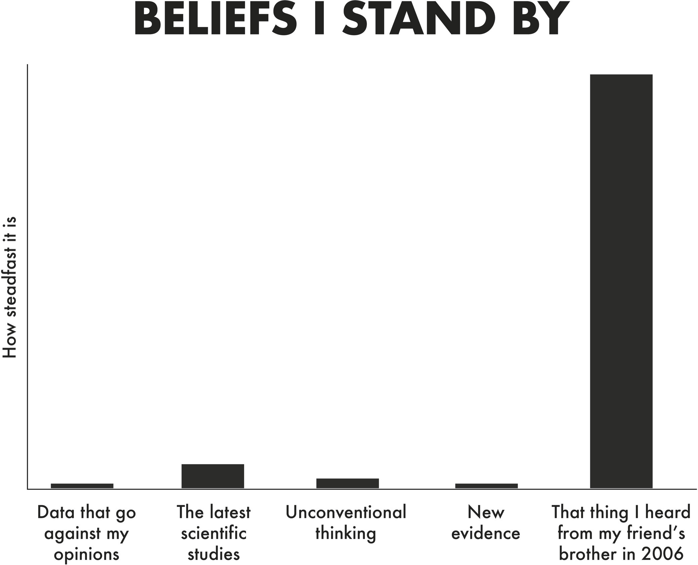

One of my beliefs is that we shouldn’t be open-minded in every circumstance. There are situations where it might make sense to preach, prosecute, and politick. That said, I think most of us would benefit from being more open more of the time, because it’s in scientist mode that we gain mental agility.

When psychologist Mihaly Csikszentmihalyi studied eminent scientists like Linus Pauling and Jonas Salk, he concluded that what differentiated them from their peers was their cognitive flexibility, their willingness “to move from one extreme to the other as the occasion requires.” The same pattern held for great artists, and in an independent study of highly creative architects.

We can even see it in the Oval Office. Experts assessed American presidents on a long list of personality traits and compared them to rankings by independent historians and political scientists. Only one trait consistently predicted presidential greatness after controlling for factors like years in office, wars, and scandals. It wasn’t whether presidents were ambitious or forceful, friendly or Machiavellian; it wasn’t whether they were attractive, witty, poised, or polished.

What set great presidents apart was their intellectual curiosity and openness. They read widely and were as eager to learn about developments in biology, philosophy, architecture, and music as in domestic and foreign affairs. They were interested in hearing new views and revising their old ones. They saw many of their policies as experiments to run, not points to score. Although they might have been politicians by profession, they often solved problems like scientists.

**DON’T STOP UNBELIEVING**



As I’ve studied the process of rethinking, I’ve found that it often unfolds in a cycle. It starts with intellectual humility—knowing what we don’t know. We should all be able to make a long list of areaswhere we’re ignorant. *Mine include art, financial markets, fashion, chemistry, food, why British accents turn American in songs, and why it’s impossible to tickle yourself*. Recognizing our shortcomings opens the door to doubt. As we question our current understanding, we become curious about what information we’re missing. That

search leads us to new discoveries, which in turn maintain our humility by reinforcing how much we still have to learn. If knowledge is power, knowing what we don’t know is wisdom.

**This document was truncated here because it was created in the Evaluation Mode.**