Electronic Magazine: Multidisciplinary Journal of Science and Technology, Selected Fields Journal in Telecommunications (JSAT), October 2013 edition.

Episode 3, Number 10.

To optimize network performance, survey the flow matrix.

# Tran Cong Hung, Nguyen Khoi, Nguyen Xuan Phi, Member, IEEE.

Summary-- The flow matrix has many applications in various fields and plays an important role in computer network management. With the input as a flow matrix, we

Computational techniques can be used to solve computer network problems such as bandwidth utilization, load balancing, and improving service quality. Therefore, the article will analyze estimation techniques and the application of flow matrix in computer networks.

Indexing term--Load balancing, shortest path matrix.

The first link, the use of bandwidth, service quality.

1. INTRODUCTION

the rapid development of the Internet and its accompanying effects

The measurement of network traffic plays an important role in how network service providers and network operators manage and plan network operations. For example, the increasing number of data centers and the emergence of cloud computing are making this measurement more complex, where content or service providers use load balancing to adapt flexibly to user needs. Understanding the flow of traffic in such networks will help improve operations.

This article is divided into 5 parts: part 1 introduces the concept of flow matrix and its applications, part 2 presents related works, part 3 introduces estimation techniques and routing problems, part 4 is the conclusion.

In our experiment and evaluation, part 5 is the conclusion and future work.

1. RELATED PROJECTS

There have been many studies conducted on TM.

To estimate the TM more accurately. Many techniques have been introduced in [1], [2], [3], [4] and the results have been applied to routing as in [5], [6], [7], [8], [9], [10], [11].

To optimize network performance, [12] is used. However, traffic demands are constantly changing, so we need to find computing techniques that ensure time and accuracy.

1. ESTIMATION TECHNIQUES AND ROUTING ISSUES
2. Linear programming (LP)

The dynamics, management, and security of IP networks today, as well as emerging services.

The Traffic Matrix (TM) - representing the flow of data from each source to each destination through a network (which we call Source-Destination (SD) pairs) - is an important piece of information needed to plan, manage, and understand any network operation. Unfortunately, direct measurement requires expensive additional infrastructure support, so equipping the entire IP network to collect that data is challenging. There have been several methods introduced to estimate the traffic matrix using estimation techniques to give us the most accurate results compared to the

We can form a system Y = AX where Y is the number of links.

A is the routing matrix, X is the flow matrix. In that system, we know Y from SNMP data, we know A from routing policies, all we have to do is solve the system to find X.

For the problem of estimating the flow matrix, imposing a set of constraints on the flow.

Linear relationships can be described by the system Y = AX, so the basic problem is.

It can be easily formed by using the LP model and standard techniques can be used to solve it. Knowing that the number.

The amount of Yl links must be the sum of all the needs for accessing and using link l, the LP model is defined as the optimization of an objective function.

quality

In which wj is the weight of pair SD j. The objective function follows the associated constraints.

Translate to english. Grammatically correct, never break words. Remove quotation marks at the beginning and end of the result, return only translated text, do not include Translate to english. Grammatically correct, never break words. Remove quotation marks at the beginning and end of the result, return only translated text, do not include [[original_text]], preserve line break.

and limit the conservation of flow.

The draft was received on September 11, 2013. Accepted: October 25, 2013.

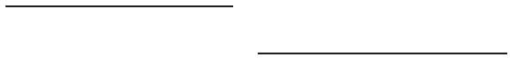Tran Cong Hung, Assoc.Prof.Dr. works with the Posts and Telecommunications Institute of Technology Vietnam (email: conghung@ptithcm.edu.vn).

Nguyễn Khôi, KS. works with the Vietnam Telecommunications Technology Academy (email: nguyenkhoi0909@gmail.com).

Nguyen Xuan Phi, MSc. works with the Vietnam Telecommunications Technology Academy (email: phinguyenxuan@agribank.com.vn).

and positive limitations.

If using a function is the linear combination of all.

các

SD

các

vậy là khả thi như ng This is. no must là những giải pháp đư ợc nhắm tới. ``

1. 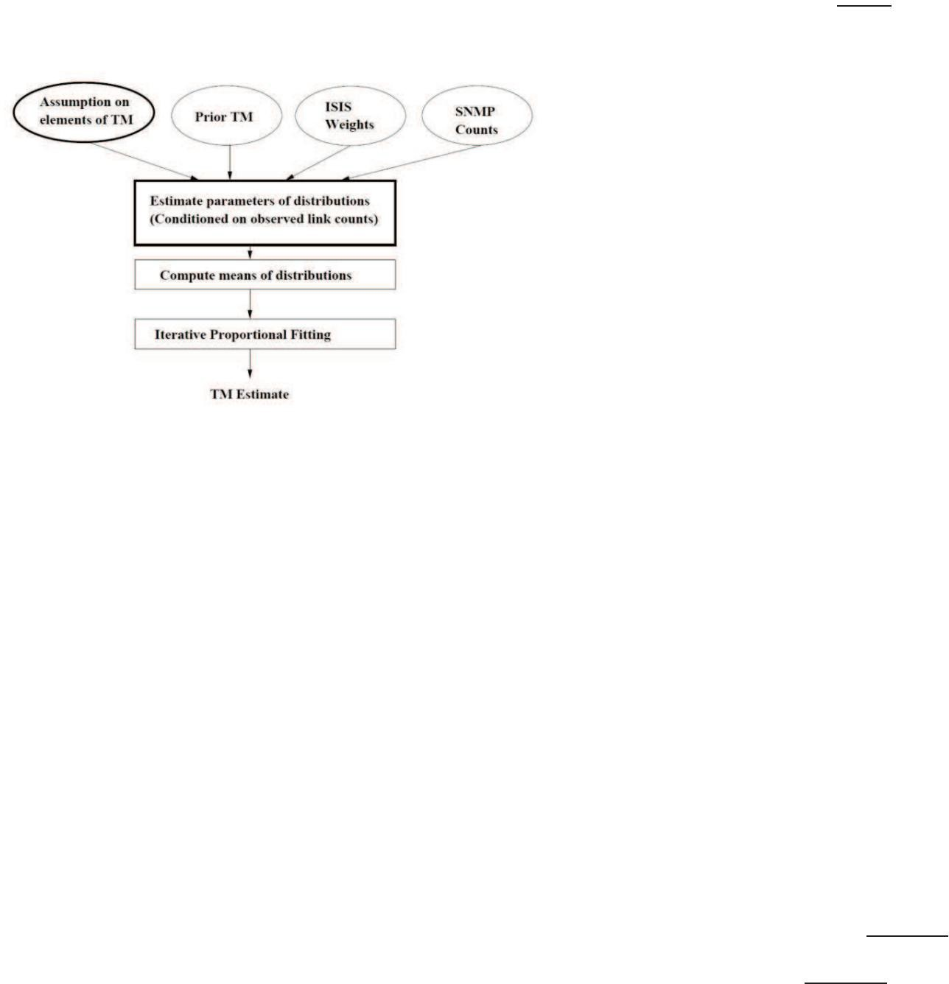Statistical method.

In which Xij is the element of the matrix representing force from i.

To j; Ri represents the disgusting elements associated with "leaving".

"khỏi" i; Aj represents the attractive elements associated with "going" to j; and fij is the friction coefficient from i.

to j.

In our context, we can naturally understand Xij as the amount of network traffic accessed at position i and exited at position j, the system.

The thrust force Ri is the flow rate accessing the network at position i and the absorption coefficient.

dẫn

khi

thông tin cục bộ cụ thể cho các cặp SD khác nhau. Hệ số ma sát suy diễn là một bài toán tư

Hình

Có

Mặc dù các giả định đư

trư

các

ra

kết đư

Với

là

Theo đó, cần phải tính gần đúng ma trận ma sát thực tế bằng cách sử dụng các mô hình có ít tham số hơn. Điểm chung

hằng số đối với các hệ số ma sát, đư

The geographical location is not the main factor in today's Internet compared to ISP routing policies.

1. Simple gravity model.

In this very simple gravity model, M. Ericsson, M. Resende, and P. Pardalos aim to estimate the flow of traffic between border links.

Ký hiệu các liên kết biên bằng l1, l2, … họ ư

và

TM.

vào

, And

represents

λm}, represents the average velocity vector (meaning each λj represents the average velocity of the pair SD Xj).

After obtaining the parameters, the next step is to calculate the conditional mean for the distribution related to each component of the TM. The step is.

The final adjustment is usually applied to the result of the corresponding step of the iterative proportional fitting (IPF) algorithm. The IPF algorithm adjusts the values of the estimated flow matrix so that the error related to the sum of rows and columns is minimized.

The number corresponds to the flow of access out of the network through the link.

The gravitational model can then be calculated using one of two methods.

or

1. Gravity model [2], [3].

Các mô hình trọng lực, lấy tên từ định luật hấp dẫn của Newton, thư

Phư

T(li , lj) là tích của lư

trong khi phư

1. Mô

M. Ericsson, M. Resende và P. Pardalos phát triển các phư

Crossbar access traffic (crossbar link to crossbar link): They believe that the traffic transmitted through the crossbar

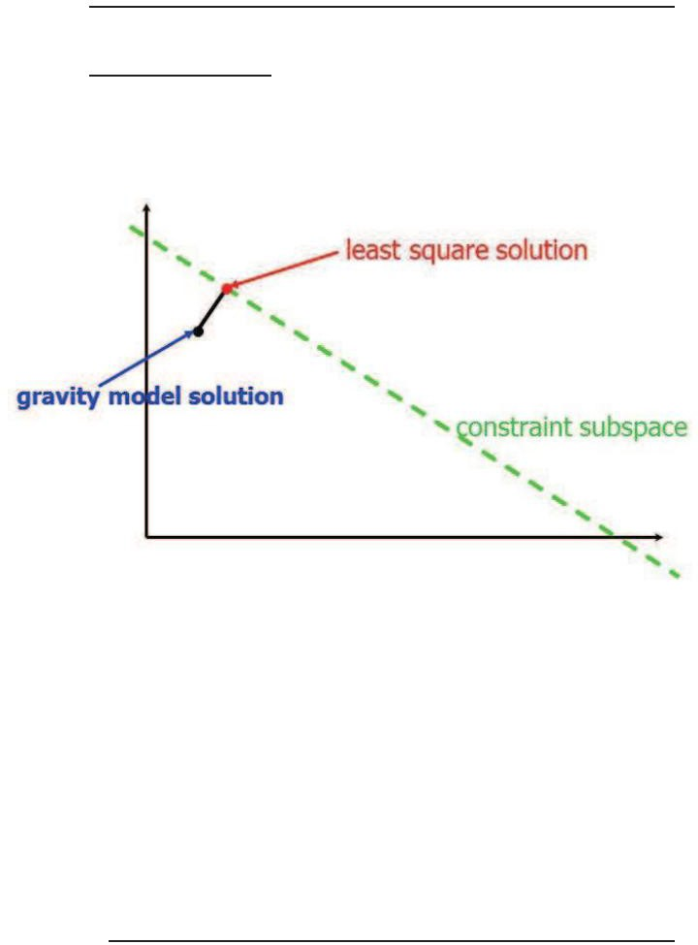

__�_

Figure 2. Illustration of the solution to the smallest square equation [2], [3]

To minimize the distance from X0 to Xg, separate the least possible values

can be used to solve quadratic equations subject to layer cutting constraints. As the result may contain negative values, the negative values will be replaced with 0 and then IPF will be performed to obtain a non-negative solution that satisfies

the constraints.

F. Routing

Routing based on destination and based on source/flow

from this crossbar network to another crossbar network is negligible.

External access traffic (access link to crossbar link): They apply the assumption of proportionality as the basis for the gravity model on the crossbar network: meaning that the traffic accessing a crossbar device

specifically from each corresponding access link to the traffic on that access right link. They assume that all traffic from a single access link to a specific crossbar device will exit the network on the same crossbar link (determined by IGP and BGP routing configurations).

Inward access traffic (crossbar link to access link): Network operators have limited control over the inbound traffic to their crossbar networks. Therefore, they assume that the inbound traffic from a specific crossbar link is divided among the access links according to their outbound traffic ratio.

Internal access traffic (access link to access link): They believe that the portion of internal access traffic from a specific access link ai

to a second access link aj is proportional to the total access traffic

to the network at ai

, and calculate the traffic between the

links by normalization.

1. Layer cutting [2], [3], [4]

Capturing network traffic is a matter of determining the access matrix from the beginning to the end of the link load. The link load is.

tổng của các phần tử ma trận lư

liên kết đó và vì vậy M. Ericsson, M. Resende và P. Pardalos nhìn thấy vấn đề như

T

(,2

đi

T

viết .

hệ

Hai

định

Họ

BẰNG:

Strong emphasis on the optimization process and the achievable outcomes: destination-based routing and source-based or flow-based routing. Common routing protocols such as OSPF, EIGRP, or IS-IS adhere to the routing model.

The general link and routing structures often have more variables than constraints, so Y = AX is highly constrained and does not have a unique solution. Their approach is not to combine additional constraints but to use a gravity model to obtain an initial estimate of the solution, which needs to be adjusted to meet the constraints. It is important to reduce the size of the problem to make the solution easier to manage.

1. Gravitational force [3], [4].

Gravity is the combination of the gravitational model and.

chụp cắt lớp nhằm khai thác điểm mạnh của cả mô hình trọng lực

BưTớc

từ mô hình trọng lực tổng

Bư

dựa

Routing aggregation, as illustrated in Figure 2. Whenever two flow streams with the same destination intersect, they will be merged and sent over the same interface. This can cause traffic overload on some links, while others remain lightly utilized.

X0

phút

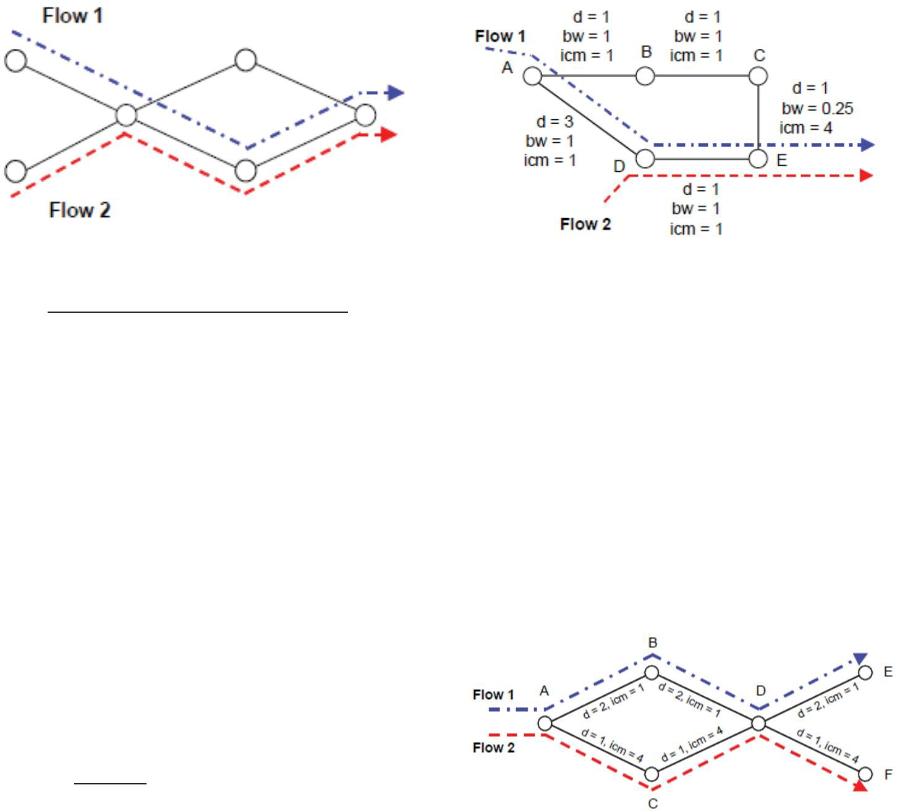Hình

Định

Trong trư

tác động ngầm và do đó tối ư

đư

(“băng

¯

Hình

Để

là

đã đư

nút BCE. Tuy nhiên, liên kết CE có băng thông chuẩn hóa nhỏ hơn là 0,25 và do đó đóng góp vào M với thông số dung lư

thông

Optimizing routing based on the concept of multipath has some advantages over the pure shortest path approach, as illustrated in the network scenario in Figure 4.

The parameter [[original_text]] represents the bandwidth of link i, while di.

refers to its latency value. Therefore, the routing algorithm takes the sum of all the latency values towards the destination node and adds

the bandwidth component, the inverse of the minimum bandwidth.

Figure 5. Sample fish routing with multiple data [5], [6].

Assuming we have two flow streams with different destinations.

along the path ("bottleneck"). From everything there isn"ể"hello, có đư ờng dẫn có một số nút chung. Đặt A là nút đầu tiên

tùy

nơi hai luồng kết hợp với nhau và D là nút chung cuối cùng

8.

đư

dọc

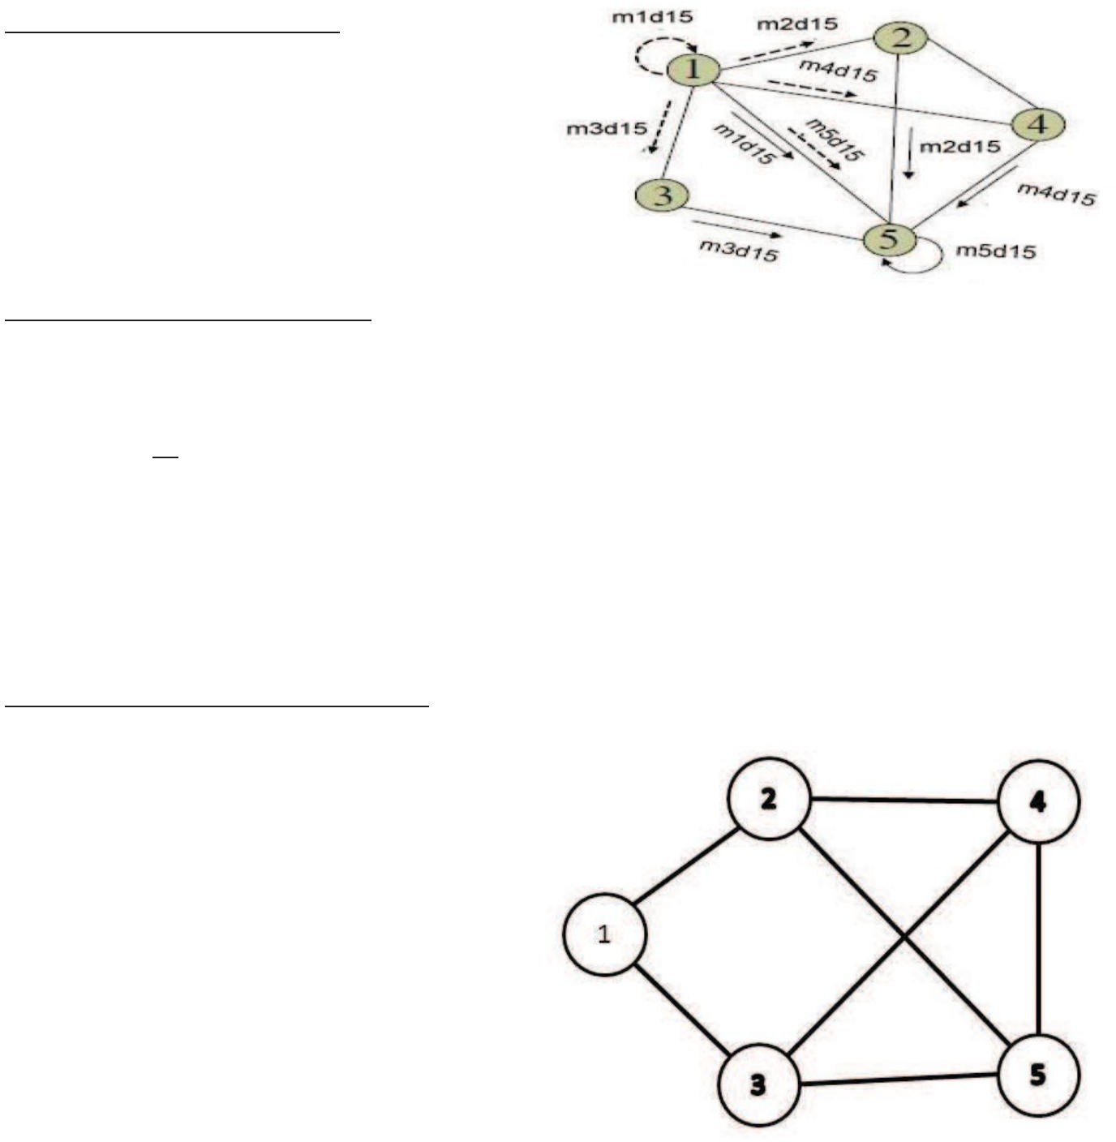Đa

Một tính năng khác của các giao thức định tuyến có ảnh hư

It can be implemented in the form of the concept "multiple paths with equal costs".

Whenever a router can reach a destination node through a.

The number of paths with equal data will evenly distribute the amount of traffic across all corresponding outgoing interfaces.

Optimize network - reduce link usage.

The use of links [7], [8], [9], [10], [11].

Network congestion rate refers to the maximum value of all link utilization speeds in the network, which is denoted as.

The usage rate of each link is determined as follows.

In which V is the set of nodes in the network and is the capacity of the link.

Figure 6. Load balancing routing for two phases.

Trong

Vì

(i,j),

là

Giảm

Lư

lư

Giảm

ISP

lư

là

Trong cấu trúc liên kết mạng phổ biến, OSPF thư

Đư

hư

Việc

One of the solutions is to use.,g is the value of the demand allocation rate of the SD pair (p,q) through node m, and the constraint is

1. RESULTS OF EXPERIMENT AND EVALUATION

In this section, we have tested our solution on various structures.

Different network structures. To check the results, we use Matlab[12] and the number of randomly generated links. We simulated a situation where the network has a very large traffic load and found that using links will perform better for smaller network structures.

# t

When there are interconnected values in use.,t can be computed on each link with input as a flow matrix. To find .setlinear programming must solve constraints on content.

The amount of connectivity and the demand for flow from the flow matrix (estimated by the techniques above). However, this is a problem.

It is difficult to solve because the number of SD pairs is greater than the number of network nodes, resulting in a set with too many elements.

Figure 7. Five-node linked structure.

One of the solutions is to use Load Balancing Routing.

First, the flow demand from the source is balanced on the intermediate nodes, and then the flow demand will be transmitted over.

the shortest paths to the destination.

Figure 12. Optimize the structure of a 20-node network.

1. CONCLUSION

Figure 8. Optimizing the structure of a five-node network.

Figure 9. Structure of a moving node.

The proposed article suggests optimizing network performance with a flow matrix as input. When estimating the flow matrix size, we must accept the error from the estimated flow matrix to the actual flow matrix. In order to have the most accurate access flow matrix, we need to improve the estimation technique. Our experimental results show that the larger the connectivity structure, the less the use of connectivity. Therefore, we will also need to improve our solution, such as balancing.

The results we achieved with large networks, with many interconnected nodes, show that we have utilized our network resources better.

We found that the capacity of the links is better utilized. When a link has a large amount of access traffic, the capacity will be divided.

Sharing with other links and network performance will be improved.

Tuy

cập

Nghiên

cho các ISP và chúng tôi có thể thu thập kết quả tốt hơn và thiết thực

tôi dự định kết hợp phư

THẨM QUYỀN GIẢI

Hình

1. A. Medina, N. Taft, K. Salamatian, S. Bhattacharyya và C. Diot (2002), "Ước
2. Yin

"Tính toán chính xác nhanh các ma trận lư

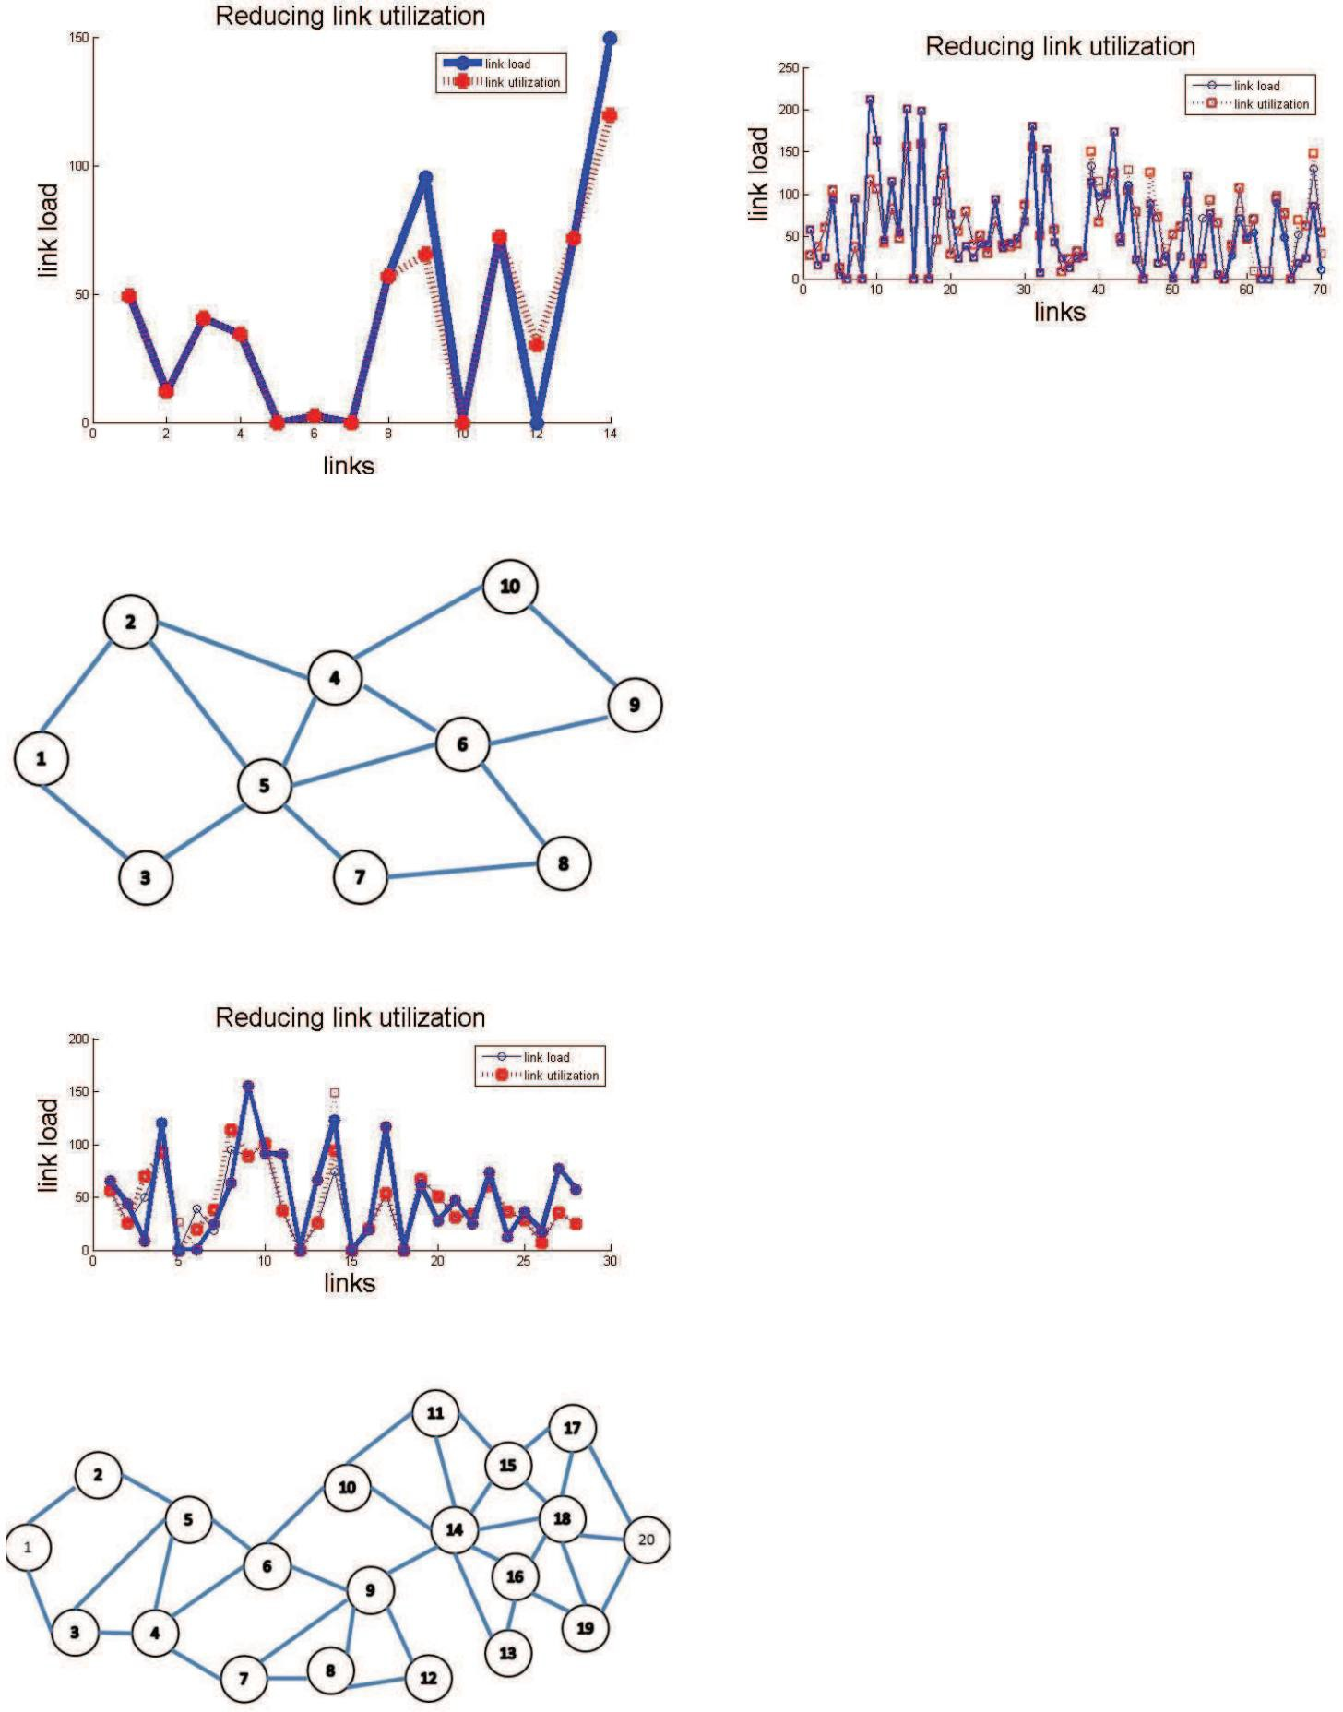

1. M. Ericsson, M. Resende và P. Pardalos (2002), "Một thuật toán

Định

1. J. Cao, D. Davis, S. Vander Weil, và B. Yu (2000), "Chụp cắt lớp

Hình

1. MGC
2. A.

thư

1. B. Fortz, M.

Internet

1. Ritesh
2. Thomas

ư

1. M.Roughan,

Kỷ

TRẦN

Việt

Ông

thông

Ông

of the University of Technology in Ho Chi Minh City, Vietnam in 1995.

He received a master's degree in telecommunications engineering from the postgraduate department of the University of Engineering and Technology at Hanoi University of Science and Technology, Vietnam, in 1998.

He received a doctorate degree at the Hanoi University of Technology, Vietnam, in 2004.

The main research field of him is various themes.

Numbers and methods for measuring performance B - ISDN, QoS in high-speed networks, MPLS.

Currently you are an Associate Professor, Doctor of the Ho Chi Minh City University of Technology and Communications, Vietnam.

1. Eiji Oki and Ayako Iwaki (2009), "Two-phase flow routing with flow matrix" Networks and Computer Communications.

NGUYEN KHOI was born in 1987 in Vietnam.

1. Marija Antic, Natasa Maksic, Petar Knezevic and Aleksandra Smiljanic (2010), "Two-phase load balancing routing for OSPF networks" IEEE Journal on selected areas in communications.
2. [http://www.mathworks.com](http://www.mathworks.com/)
3. Vijiay Kumar Adhikari, Sourabh Jain and Zhi-li Zhang.

From the flow matrix to the routing matrix.

Characteristics of PoP provisioning for Tier 1 ISPs.

1. A. Omidvar and HS Shahhoseini (2011), "Estimating the intelligent IP flow matrix using neural networks and genetic algorithms".

I have obtained the BE certificate in Information Technology from the Posts and Telecommunications Institute of Technology (PTIT).

Vietnam, 2010.

Will receive a Master's degree in PTIT in 2013 specializing in.

In Networks and Data Transmission.

He is currently a Network Administrator.

at Metro Cash & Carry Vietnam, 2013.

NGUYEN XUAN PHI was born in Vietnam in 1980.

I obtained a Bachelor's degree in Information Technology at the Ho Chi Minh City University of Technology in 2006.

AUTHOR

I received a Master's degree from PTIT in 2012, majoring in.

In Networks and Data Transmission.